**Skills**

**Ju-Young (Alex) Kim**

**(he/his/him)**

**<kim2975@purdue.edu / alex99.young.kim@gmail.com> [wndudrla0211.github.io]**

**615 Main Street, Lafayette, IN**

**(765)409-7565**

**Programming Languages**

C / C++

Python

Javascript

HTML / CSS

**Video Editing**

Adobe Premier Pro

Sony Vegas 13

**2D/3D + (Tools)**

Adobe Photoshop

Animation Paper

Blender

Maya

Houdini

Unreal Engine 5

Zbrush

Processing

Visual Studio

Eclipse

**Languages**

English, Korean

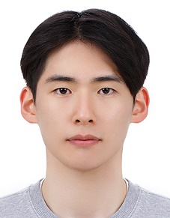**Education**

University High School August 2014 – May 2018

Purdue University August 2018 – Present

BS Animation and Visual Effects

BS Game Development

**Employment**

Somi Somi Ice Cream Restaurant December 2017 - April 2018

Irvine, CA

Team Member

°Providing a fun and unique dessert experience by combining Korean street food culture with high quality ice cream

Yummy Time Korean Restaurant October 2019 – February 2020

West Lafayette, IN

Server

°Offering authentic, delicious Korean cuisine in a welcoming environment

Military Service August 2020 – February 2022

South Korea

Army

°Ensuring the national defense of South Korea, fostering discipline, and promoting leadership

Kids’ Café March 2022 – June 2022

South Korea

English Tutor

°Tutoring and mentoring children in a fun, supportive environment

Paris Baguette June 2023 – August 2023

Glendale, CA

Bakery Front Count Associate

°Preparing, and offering delicious pastries, coffees, and cakes in a fun, supportive environment

Insomnia Cookies December 2024 – Present

West Lafayette, IN

Baker

°Preparing and baking a variety of high-quality cookies and desserts in a fast-paced environment, ensuring freshness and excellent customer satisfaction

**Team Projects**

Purdue SIGGD Club (Purdue ACM’s Special Interest Group for Game Development) September 2024 – May 2025

Art Team

°Game Jam September 2024 – September 2024 (13th~ 15th)

https://arry424.itch.io/inchainity2